**Joan of Arc**

John of Arc was a young peasant girl who helped lead the French to victory against the English. Since her childhood, she had big dreams and goals to save France by expelling its enemies, and to install Charles as its rightful king. Driven by her desire to defend her country, she convinced the prince to allow her to join the army. She asked the prince to give her an army to lead off Orleans, then under siege from the English. Seeing her valor and zeal, the prince granted her request. Under his courageous leadership, the French army successfully defeated the English and forced them to retreat. Her reputation spread far and wide after such miraculous victory. After many victories in battles, she was captured during an assault by the English and was sentenced to death. However, her fame only increased after her death and she was declared a National Symbol of France by Napoleon in 1803. Joan's strength of will resonated with feminist suffragettes, who used her image in magazines and on posters to promote their cause. **Her enduring faith and unshakeable courage made her a powerful feminist icon and she continues to inspire the gender equality movements throughout the world**.

**Serena Williams**

Serena was born in Michigan and started playing tennis at the age of 3. Her game and dreams were nurtured by her father who always supported her in her quest to become a professional tennis player. She had to face gender discrimination in the court compounded by the dark color of her skin as white parents talk used to talk about her in a derogatory manner during tournaments. **However, her desire to achieve big was too strong to be overshadowed by such hurdles**. As a result of her consistent hard work, she rose to become one of the most successful female tennis players of all time. **Today her name is considered synonymous with speed, power and success**. With 22 Grand Slam titles on her name, **she holds the record of winning more Grand Slam titles than any man**. During a press conference in 2016, when a reporter asked her how she felt that people were calling her one of the greatest “female athletes” of all time, her response took the gender out of the question “I prefer the words: one of the greatest athletes of all time”. Serena has used her profile and fame to advocate for women rights, particular for equal pay for men and women in sports.

**Angela Markel**

Angela Markel has been serving as the Chancellor of Germany since 2005. She is the first woman to serve as the Head of Government in Germany. She has been widely described as the de facto Leader of the EU and one of the most powerful persons in the world. She has played a monumental role in keeping the EU together despite the Eurozone crisis. It was her strong leadership that steered the German Economy out of instability during the 2008 Global Economic Crisis. Her very presence as an East German woman at the helm of a male-dominated with its roots in West Germany has changed not only the party but arguably also German society. She is Germany’s first female political leader and famously left many men behind her on the way up. This has in turn resulted in new policy direction on Gender Equality such as family and women’s rights – including the recent decision to introduce female quotas into the federal parliament.

**Gender Equality in Nordic Countries (Iceland, Norway, Finland, Sweden 🡪 1,2,3,4 in Gender Equality Index)**

The Nordic countries consistently stand out in the **World Economic Forum’s annual Global Gender Gap Report**, which measures how well countries are doing at removing the obstacles that hold women back. All Nordic countries have reached a 99-100% literacy rate for both genders.

* High Female Labor Force Participation (3/4th women are in the labor force)
* Salary Gaps b/w Men and Women are among the lowest in the World
* Policies like Mandatory Paternity Leave and Public Day Care System made it possible for parents to combine work and family
* More women in the workplace 🡪 **Finland** has the largest female labour-force participation, **as 83% of women, including mothers, work full time**
* There have been successful policies aimed at promoting women leadership. **In Norway, publicly listed companies are required to have 40 percent of each sex on their boards.**

Commitment to Gender Equality in Politics 🡪 Sweden has among the highest percentages of women in parliament in the world (**44.7%)**

* CEO of IBM = Ginni Rometty
* CEO of Pepsi = Indra Noyi
* CEO of General Motors = Mary Barra

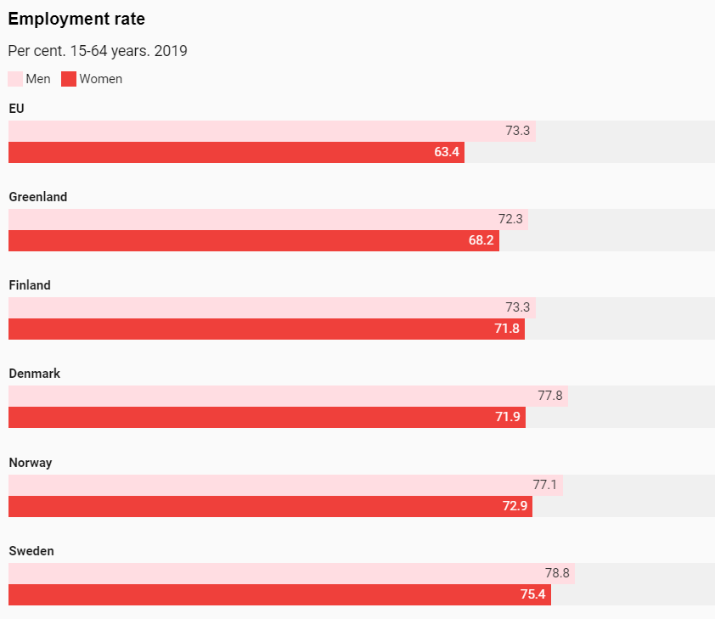

**Japan and Germany after World War 2**

Japan lay in ruins after World War 2. A significant proportion of the Japanese population was wiped out during World War II, including an estimated 210,000 people in the atomic bombings of Hiroshima and Nagasaki alone. A quarter of Japan’s national wealth evaporated during the war and the country was occupied by the US after its formal surrender.

In Japan and Germany, economic turnaround was driven by firms with strong employee loyalty gained by the promise of rising wages and jobs for life, as well as innovative products that were exported worldwide. Whether they were pre-war conglomerates such as Mitsubishi or Sumitomo, smaller pre-war companies like automaker Toyota or new firms representing now-familiar brands - such as consumer electronics giant Sony and car manufacturer Honda - Japanese firms were rigidly hierarchical institutions that closely resembled a family, according to experts. Tight coordination by the powerful industry ministry helped drive economic growth. Human infrastructure provided a very favorable environment. Both countries had a wide pool of highly motivated, disciplined, diligent and quick-to-learn laborers prepared to work long hours for (initially) quite low wages and really committed to serving their nation and companies

**Japan became the second largest economy in the world after the US in 1968, experiencing average growth of up to 9% per year between 1955 and 1973. The German “Wirtschaftswunder” economic miracle accelerated even faster, transforming West Germany into the world’s second largest economic powerhouse by the 1950s.** **Japan is the world's third largest automobile manufacturing country, has the largest electronics goods industry, and is often ranked among the world's most innovative countries leading several measures of global patent filings.**

**Malaysia – Mahatir Muhammad**

Malaysia´s economic development was remarkable, given its troubled beginnings in the early 1960s and the ethnic partitions that were inherited from centuries of segmented economic development. Since its formation in 1963, Malaysia's economic performance has been one of Asia's best. Real gross domestic product (GDP) grew by an average of 6.5% per year from 1957 to 2005. High levels of foreign and domestic private investment played a significant role as the economy diversified and modernized. Malaysia is one of the world's largest exporters of semiconductor components and devices, electrical goods, solar panels, and information and communication technology (ICT) products.

In the 1970s, Malaysia began to imitate the four Asian Tiger economies (South Korea, Taiwan, the then British Crown Colony of Hong Kong, and Singapore) and committed itself to a transition from being reliant on mining and agriculture to an economy that depends more on manufacturing. In the 1970s, the predominantly mining and agricultural based Malaysian economy began a transition towards a more multi-sector economy. Since the 1980s the industrial sector has led Malaysia's growth. High levels of investment played a significant role in this.

**Central planning under Mahathir Muhammad** has been a major factor in the Malaysian economy, as government expenditure was often used to stimulate the economy. Since the commencement of the **Malayan Five Year Plan**, the government has used these plans to intervene in the economy to achieve such goals as redistribution of wealth and investment in, for instance, infrastructure projects

During Mahathir's tenure as prime minister, Malaysia experienced a period of rapid modernization and economic growth, and his government initiated a series of bold infrastructure projects. Mahathir was a dominant political figure, winning five consecutive general elections and fending off a series of rivals for UMNO's leadership.

**Malaysian Proton Car Industry Revolution to reduce dependence on the British**

Back in 1983, the Malaysian government decided they wanted to set about creating a national car brand. The government decided to leverage its position to impose heavier taxes on foreign companies, thereby giving this domestic brand a competitive advantage.

The people were filled with pride and in full support of the country’s first national car brand. One of the factors that got everyone to support the projects was the rationale behind the formation of a car brand, given by then Prime Minister of Malaysia, Mahathir Mohamad. What was his idea? To have a domestic car manufacturer that would be able to produce in high volumes, therefore driving up economies of scale, similar to Henry Ford’s original idea of reducing costs via mass production. However, Mahathir’s vision was much deeper than it seemed on the surface. He planned to use the national car project as a Launchpad into industrializing the entire nation. At that time, Malaysia relied heavily on agriculture, namely palm oil and rubber industries. By establishing PROTON, an entirely new supply chain would need to be formed to cater to its needs, from suppliers to distribution and aftersales. Furthermore, the project aimed to enhance the engineering and manufacturing capabilities of the local workforce, enabling them to easily contribute to other industries or create entirely new ones within the country. All these steps would help put Malaysia on a fast track to becoming an industrialized nation, many of the world’s most famous examples of which – the U.S., Japan and Germany – owe much of their industrialization to the strengthening of their automotive industries after World War 2.

**As Mahathir had envisioned, PROTON did serve its purpose beyond making affordable cars, as it catapulted the nation’s entire economy with a series of new manufacturing and engineer-driven industries.**

**Singapore – Lee Kuan Yew**

Anti-corruption, Good Governance, Civil Service, Population

Lee Kuan Yew was a Singaporean statesman and lawyer who served as Prime Minister of Singapore from 1959 to 1990, and is recognized as the nation's founding father. Lee led his party to its first electoral victory in the 1959 election, and was appointed as the state's first prime minister.

With overwhelming parliamentary control at every election, Lee oversaw Singapore's transformation into a developed country with a high-income economy within a single generation. In the process, he forged a system of meritocratic, highly effective and anti-corrupt government and civil service. Lee eschewed populist policies in favor of long-term social and economic planning. He championed meritocracy and multiracialism as governing principles, making English the lingua franca to integrate its immigrant society and to facilitate trade with the world, whilst mandating bilingualism in schools to preserve students' mother tongue and ethnic identity.

His beliefs on government transparency have been adhered to by successive administrations of the governing party, and Singapore continues to be considered as one of the least corrupt countries as compared to the rest of the world.

Lee introduced legislation giving the Corrupt Practices Investigation Bureau (CPIB) greater power to conduct arrests, search, call up witnesses, and investigate bank accounts and income-tax returns of suspected persons and their families. Lee believed that ministers should be well paid in order to maintain a clean and honest government. In 1994, he linked the the salaries of ministers, judges, and top civil servants to the salaries of top professionals in the private sector, arguing that this would help recruit and retain talent to serve in the public sector

In the late 1960s, fearing that Singapore's growing population might overburden the developing economy, Lee started a "Stop at Two" family planning campaign. Couples were urged to undergo sterilization after their second child. Third or fourth children were given lower priorities in education and such families received fewer economic rebates. In 1983, Lee sparked the "Great Marriage Debate" when he encouraged Singapore men to choose highly educated women as wives. He was concerned that a large number of graduate women were unmarried. Some sections of the population, including graduate women, were upset by his views. Nevertheless, a match-making agency, the Social Development Unit (SDU), was set up to promote socializing among men and women graduates. In the Graduate Mothers Scheme, Lee also introduced incentives such as tax rebates, schooling, and housing priorities for graduate mothers who had three or four children, in a reversal of the over-successful "Stop at Two" family planning campaign in the 1960s and 1970s. By the late 1990s, the birth rate had fallen so low that Lee's successor Goh Chok Tong extended these incentives to all married women, and gave even more incentives, such as the "baby bonus" scheme.

During the three decades in which Lee held office, Singapore grew from a developing country to one of the most developed nations in Asia. Lee said that Singapore's only natural resources are its people and their strong work ethic. Lee's achievements in Singapore had a profound effect on the Communist leadership in China, who made a major effort, especially under Deng Xiaoping, to emulate his policies of economic growth, entrepreneurship and subtle suppression of dissent. Over 22,000 Chinese officials were sent to Singapore to study its methods

